**The Conjuring 3: Release, Cast, Plot** 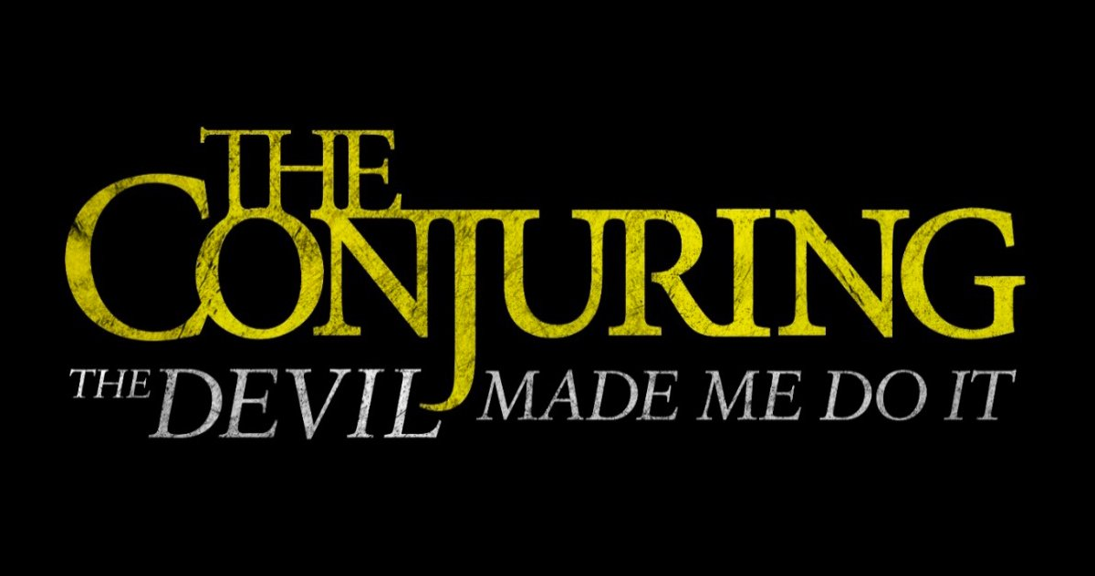

**The Conjuring 3** also known as **The Conjuring: The Devil Made Me Do It**, an American paranormal and mystical horror film written by Johnson-McGoldrick and James Wan, and directed by Michael Chaves. It’s in continuation to *The Conjuring* in 2013 and *The Conjuring 2* in 2016.

**The Conjuring 3: Cast**

Following are the cast members of *The Conjuring 3*:

Vera Farmiga being *Lorraine Warren*

Megan Ashley Brown being young Lorraine Warren

Patrick Wilson being *Ed Warren*

Mitchell Hoog being young Ed Warren

Ruairi O’Connor being Arne Cheyenne Johnson

Sarah Catherine Hook being Debbie Glatzel

Julian Hilliard being David Glatzel

Charlene Amoja being Judy Glatzel

Paul Wilson being Carl Glatzel

Sterling Jerins being Judy Warren

Shannon Kook being Drew Thomas

Steve Coulter being Father Gordon

Ronnie Gene Blevins being Alan Bono

Davis Osborne being John Beckett

Ashley LeConte Campbell being Meryl Dewitt

Mark Rowe being Sergeant Thomas

Kaleka being Jury Foreman

Andrea Andrade being Katie

Stella Doyle being Mrs. Haskett

Keith Arthur Bolden being Sergeant Clay

Nicky Buggs being witch woman #1

Rebecca Lines being witch woman #2

Fabio William being Bill Ramsey 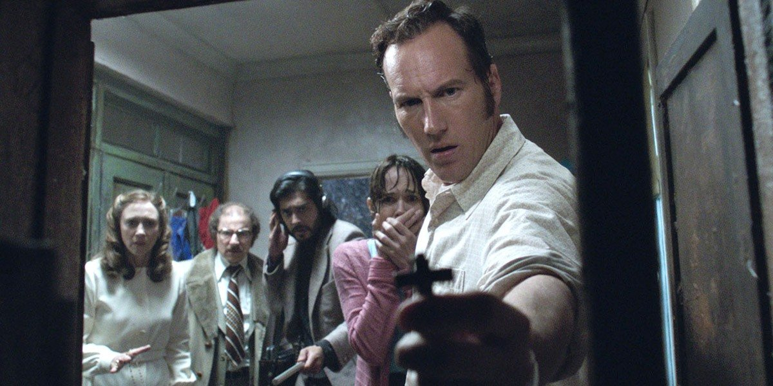

**The Conjuring 3: Plot**

**The Conjuring 3** divulges a frightening story of horror, killing and mysterious wicked that stupefied even accomplished real-life paranormal inspectors *Ed* and *Lorraine Warren*. It depicts one of the most horrifying cases from their files. The case starts with a dispute for the soul of a young boy, that lead them to encounter things which they’d never seen before, in order to mark the first time in U.S. history that a murder accused would allege devilish control as a defence for its action.

**The Conjuring 3: Release Date**

It’s planned to be delivered in the US on June 4, 2021. *Warner Bros* will be its distributor and as part of its plans for all of its 2021 films, **Warner Bros** will stream *The Conjuring 3* on the HBO Max service for a span of one month, following which the film will be withdrawn from the service till the time its schedule period is released by the normal home media. It’s delayed because of covid-19. It was previously planned to be broadcasted on September 11, 2020.